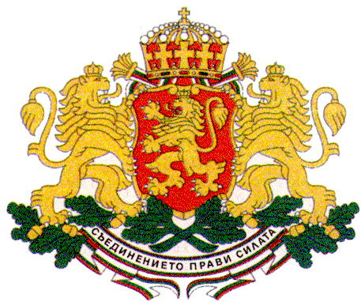 | PERMANENT MISSION OF THE REPUBLIC OF  BULGARIA  TO THE UNITED NATIONS

11 East 84th Street, New York, NY 10028, Tel: (212) 737 4790, Fax: (212) 472 9865, e-mail: bulgaria@un.int

UNICEF Executive Board
Annual Session, New York, 11 – 14 June 2018, UNHQs, CR 3

H.E. Mr. Georgi Panayotov, Ambassador,
Permanent Representative of Bulgaria to the UN

General Statements

New York, Monday, 11 June 2018

Mr. President,
I would like to thank the Executive Director Ms. Henrietta Fore for the comprehensive annual report and for her strong commitment to children’s rights.
UNICEF’s efficiency in delivering protection to children in all parts of the world is instrumental for improving children’s safety and well-being, often in the most difficult contexts. The Government of Bulgaria supports these efforts both politically and through targeted funding. The largest part of Bulgaria’s humanitarian and development assistance is realized through UNICEF.
Bulgaria commends UNICEF for the progress made in the implementation of the new Strategic Plan. We welcome also the vision of the new Executive Director to focus on the rights of children in the second decade of life as a crucial moment for acquiring the necessary competencies and skills for their future professional realization and active participation in society as agents of positive social change and development.
The Government of Bulgaria has identified children’s rights as one of its key priorities on the political agenda of the current Bulgarian Presidency of the Council of the European Union and is working actively with partners to strengthen policies for children. Children’s rights feature as a major commitment in Bulgaria’s bid for Human Rights Council membership for 2019 - 2021.
All national policies related to children follow a human rights-based approach taking into consideration the best interests of the child principle and the specific needs of every child, with a particular focus on children and youth with disabilities. Special attention is paid to promoting the right to quality education for all. In 2016 the Bulgarian Government adopted a new Pre-school and School Education Act which establishes inclusive education as a state policy.
Bulgaria is a strong supporter of child rights in the context of global migration as well following the principle that a child is first a child and should be protected in all circumstances. The Bulgarian Government grants refugee and migrant children the same rights as Bulgarian children, including free of charge education, healthcare and other services, which is crucial for their integration in society.
As a co-chair of the Group of Friends of Children and the SDGs Bulgaria continues to actively promote children’s rights in all intergovernmental processes.
In recent years Bulgaria has achieved significant progress in child protection and has been recognized as a leader in the region in child care. UNICEF is an important partner in those efforts. I would like to express our appreciation to UNICEF’s Regional Director Ms. Afshan Khan for her enormous contribution to ensuring the well-being of children in our region. The positive example of Bulgaria in the child care reform and deinstitutionalization is successfully shared with countries in our region and beyond thus strengthening UNICEF’s horizontal cooperation as well. Bulgaria has the ambition to become a regional hub for children’s rights which is reflected as an underlying principle in the new Bulgaria Country Programme Document adopted by the Executive Board last September.
The strong partnership with UNICEF and the active involvement of civil society, social partners, media and the private sector is crucial for the success of all child related policies of the Government of Bulgaria and for securing funding, thus ensuring sustainability of results for children.

Thank you, Mr. President.

